**Venkataramanan** **K**

**DVI_GROUP002**

**DVI_ASSIGNMENT1PS2_BANKING DATA ANALYSIS**

**Balakavin Pon**

**Ponvani**

**Poornima J**

**Synopsis:**

DATA VISUALIZATION AND INTERPRETATION

Assignment 1 on Bank Data Analysis

Submission on 13 Dec 2019

Assignment #1 | **Data Visualization**

**Bank Data Analysis**

**Venkataramanan K | 2018AC04529**

**Balakavin Pon | 2018AC04531**

**Ponvani | 2018AC04531**

**Poornima J | 2018AC04531**

Analysed and created in collaboration of

Bits, pilani work integrated learning program



# Table of content

Table of content 3

1 | Visualization Context 4

Business Problem 4

Who 4

What 4

How 4

Primary Questions 4

# 1 | Visualization Context

## Business Problem

The bank wants to run the marketing campaign on the huge diversified product portfolio. Generally, the marketing department runs several marketing campaign times to time, the details about those campaigns are documented properly. We need to analyze the data collected during the marketing campaign and provide a recommendation or suggestions on the contributing factors for the successful purchase of the product. This enables the marketing team to focus on the significant factors to make the campaign more successful on selling the product to customers.

## Who

Marketing department leaders of the bank. They are the target audience for the analysis and outcome of the same as recommendations and suggestions towards their marketing campaign.

## What

The primary objective of this analysis is to understand and get an insight about the previously conducted market campaign on the bank products to various types of customers. The outcome of the analysis will give a direction to the marketing department to get a direction on the contributing factors for the success of the marketing campaign.

## How

The marketing campaign data have been collected over the period of time. The Exploratory Data Analysis has been conducted on the gathered data to understand the data fields and their relations to reflect the success or failure of the campaign.

At first the basic and required questions were formed regarding the analysis and the outcome of the analysis will provide the answers to those questions.

## 

## Primary Questions

## Exploratory Data Analysis:

There are around 41188 marketing campaign data are available, out of which 4640 i.e. 11.27% of people had purchased the product.

**Age distribution:**

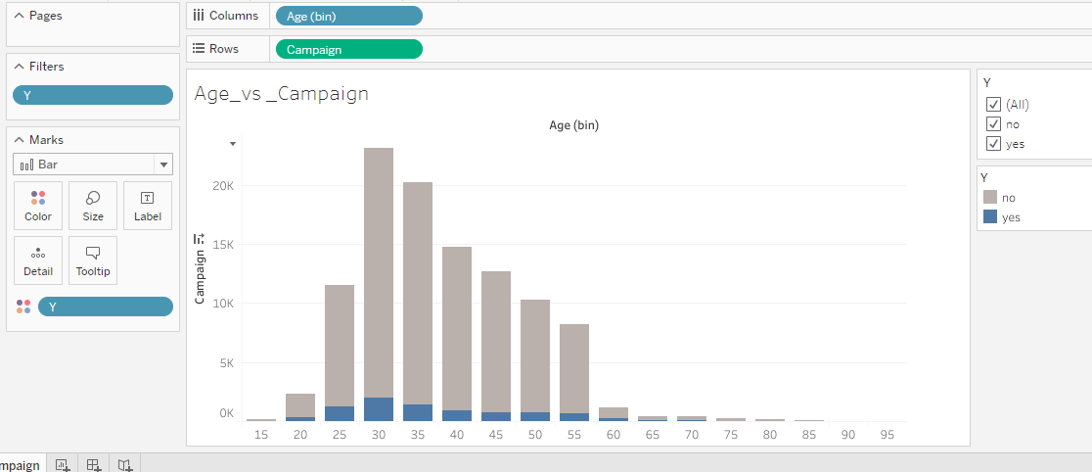

**Inference:** People between the ages 25 to 40 are active customers.

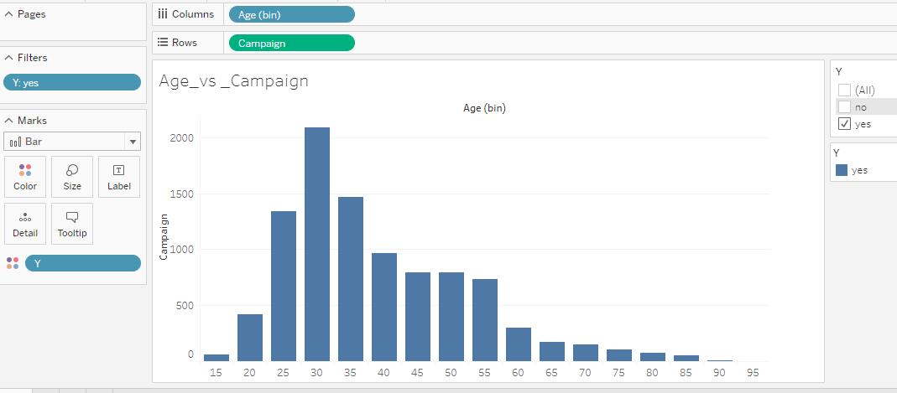

**Defaulter:** 90% of People who are Non defaulter are purchasing. 10% are unknown.

We can target the non-defaulters.

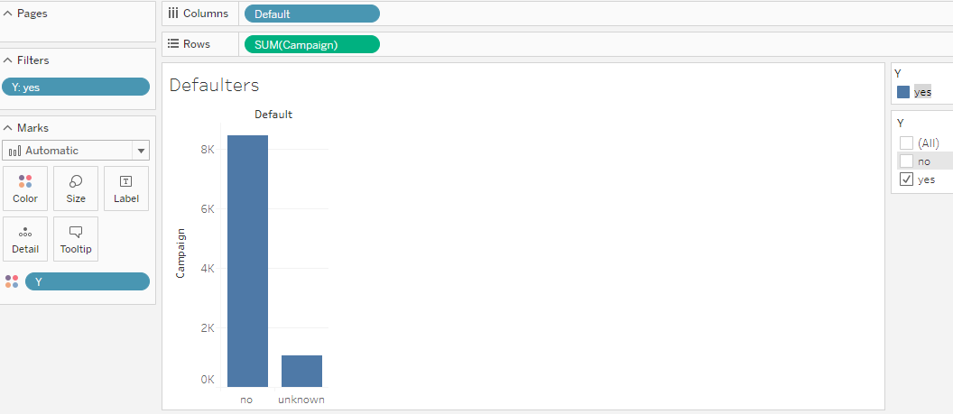

**Mode of Contact:**

83% of people are contacted via cellphone had purchased.

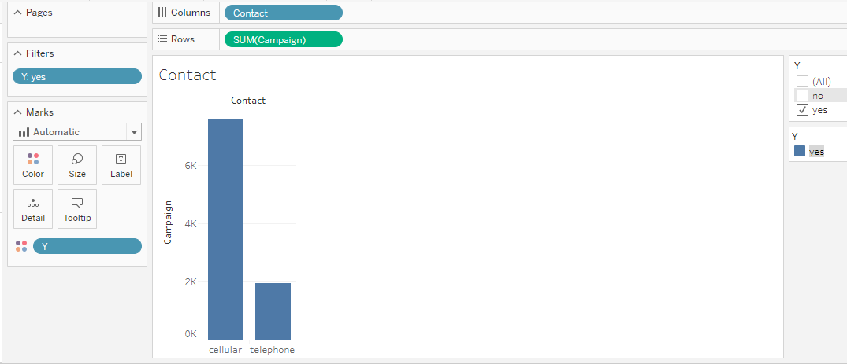

**Loan:** Has personal loan?

82% of people who are not having personal loans are purchasing.

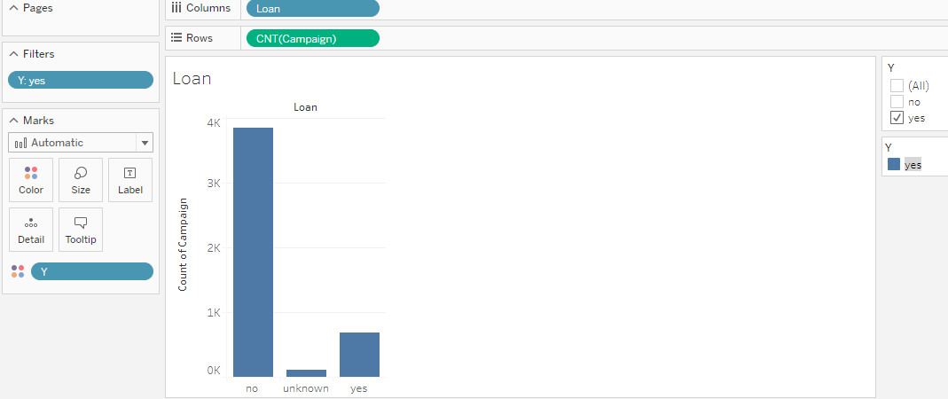

**Housing:** has housing loan?

Not a major difference between the People having/not housing loan.

54.03% of people who are having housing loan had purchased

43.66% of people who did not purchase are not having housing loan.

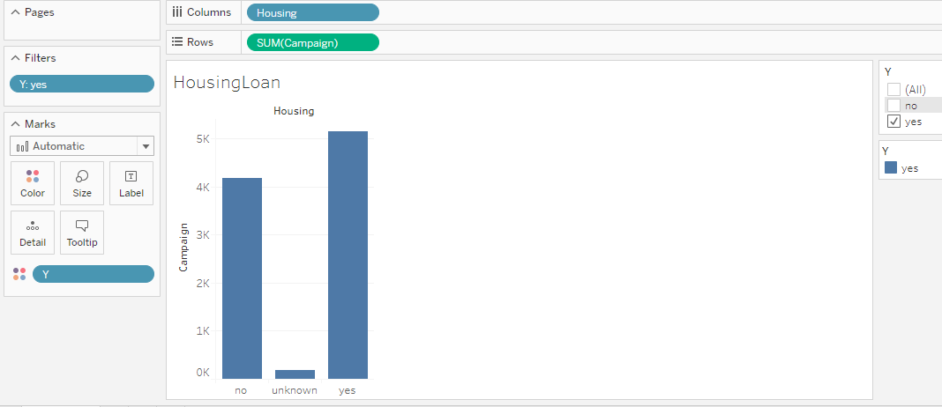

**Month:** It is observed that Dec month is having less than 2% percentage of purchase and no records for Jan and Feb. So, it is better to avoid during year end and jan&feb.

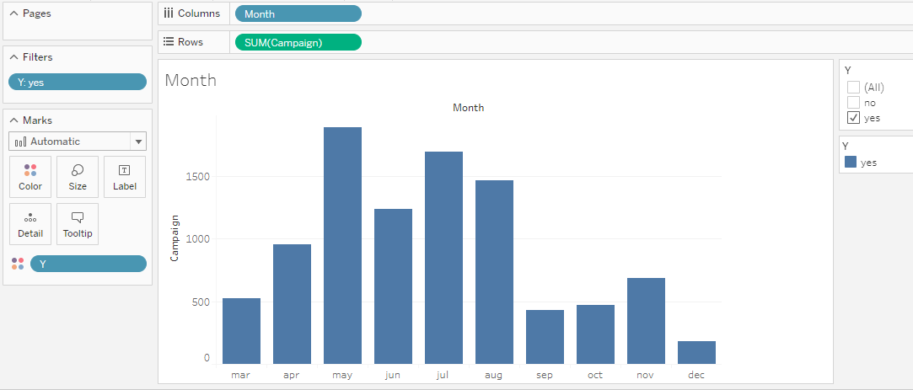

**Marital:** 50% of married people are purchasing.

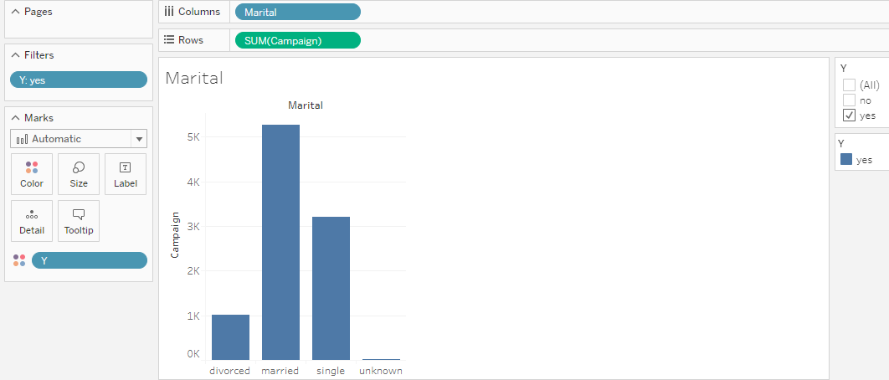

**Pdays:** (number of days that passed by after the client was last contacted from a previous campaign

999 means client was not previously contacted.)

79% -it is evident that people who are **Newly** contacted or contacted within 1st week after campaign are purchasing.

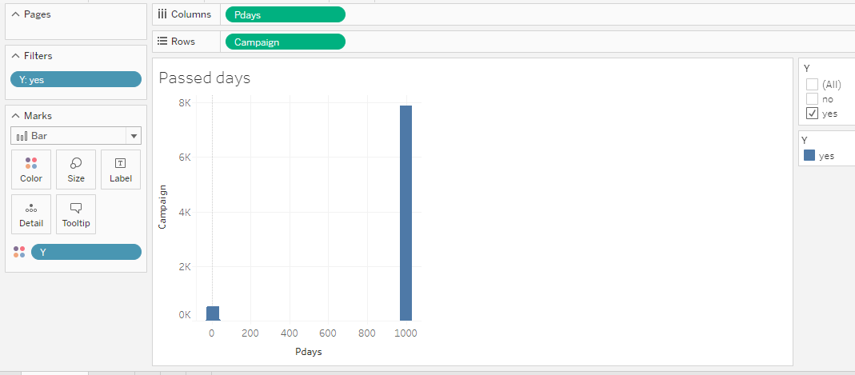

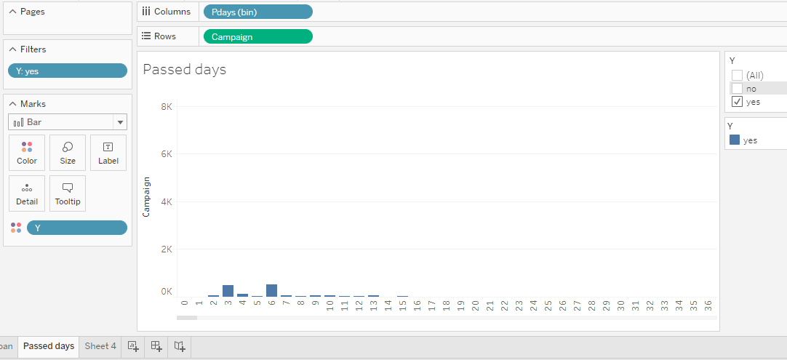

**Inference:**